Los Angeles Times: AROUND THE GALLERIES Virginia Katz at Jancar Gallery, Getting Lost in a World of Nuances By David Pagel, Special to The Times, 2008 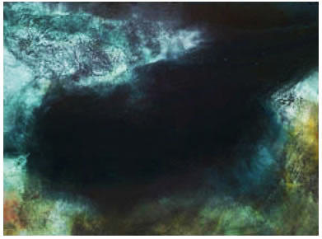
At first glance, Virginia Katz's mixed-media works on paper resemble satellite images of the Earth's surface. Tiny lines, complex shapes and organic colors seem to describe mountains, valleys and plains as well as rivers, lakes and oceans. The details are so exquisite and convincing that it's tempting to stand back and try to determine what part of the world is being depicted: The Baja coast? A Mesopotamian waterway? The Russian tundra? A Guatemalan jungle?
But too many loose ends -- or befuddling inconsistencies -- prevent you from matching any of Katz's 20 abstract images at the Jancar Gallery with a specific location. As you move in closer to the 22-by-30-inch works, it's clear that they are nonrepresentational. You get lost in a world thick with visual incidents yet unlike anything you have seen.
Katz's exceptionally nuanced works are monoprints she makes by crinkling up sheets of kitchen foil, dripping on colored inks and then running the shallow reliefs through a press, which leaves an imprint on a sheet of paper. After letting it dry, Katz draws with pencils, adds watercolor washes and gouache accents and then tops off the controlled chaos by dusting it with dry pigments.
The results have the intimacy of handmade artifacts and the unself-consciousness of serendipitous accidents. It's a felicitous fusion of taking control and letting go.
The surfaces of Katz's works have nothing in common with the slickness of digital imagery. Most impressive, her modestly scaled pieces are expansive. Each seems to bring more space into the room than its literal dimensions suggest. And each is so packed with scrappy happenstance and indescribable detail that no matter how long you look there's always more to see.
Katz makes mountains of molehills with eye-popping originality.

